1. Which are the top three variables in your model which contribute most towards the probability of a lead getting converted?

Ans 1. Based on the logistic model that we have built and their respective coefficients, the top 3 variables that contribute most towards the probability of a lead getting converted

* Lead Origin: The origin identifier with which the customer was identified to be a lead.
* Current Occupation: Indicates whether the customer is a student, unemployed or employed.
* Last Activity: Last activity performed by the customer. Includes Email Opened, Olark Chat Conversation, etc.

Model Features with coefficient values:

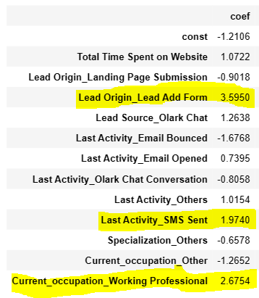

1. What are the top 3 categorical/dummy variables in the model which should be focused the most on in order to increase the probability of lead conversion?

Ans 2: The top 3 categorical/dummy variables in the model which should be focused the most on in order to increase the probability of lead conversion are:

* Lead Origin of Lead Add Form: 3.59

More focus should be on ‘Lead Add form’ from which the customer was identified as lead.

* Working Professional as occupation: 2.67

Customers who are working professional should be more actively communicated compared to other occupation like customized message and emails for more successful conversions.

* If the last activity by Customer was SMS sending: 1.97

Probability of lead conversion will increase if customer has interacted with any SMS. More follow ups and communication will be fruitful in these cases.

1. X Education has a period of 2 months every year during which they hire some interns. The sales team, in particular, has around 10 interns allotted to them. So during this phase, they wish to make the lead conversion more aggressive. So they want almost all of the potential leads (i.e. the customers who have been predicted as 1 by the model) to be converted and hence, want to make phone calls to as much of such people as possible. Suggest a good strategy they should employ at this stage.

Ans 3. Good strategies that should be employed at this stage to make the lead conversion more aggressive are as follows:

* The Interns should make more calls to ‘hot leads’ classified by the model as they have higher ‘Lead score’ and most likely to convert making them potential leads.
* Lead conversion can be increased by follow ups or call backs to customers who have been sent SMS and they have also opened the email sent.
* Interns can also call leads who are spending more time on website as they have positive correlation of being converted.
* To increase the lead conversion, interns should refrain from calls/communication to customers whose email got bounced.

1. Similarly, at times, the company reaches its target for a quarter before the deadline. During this time, the company wants the sales team to focus on some new work as well. So during this time, the company’s aim is to not make phone calls unless it’s extremely necessary, i.e. they want to minimize the rate of useless phone calls. Suggest a strategy they should employ at this stage.

Ans 4. Strategies that should employed in case the company reaches its target before the deadline are as follows:

* Instead of phone calls, using personalized emails, SMS, customized offers, social media, or chatbots to advertise and build relationships with potential leads/customers.
* Gathering feedback/reviews for existing model from other data scientists, management and the cross functional teams for model enhancement.
* Collecting feedback from existing customers to optimize conversion rates.
* Offering discounts/incentives to potential customers for any referrals/leads.